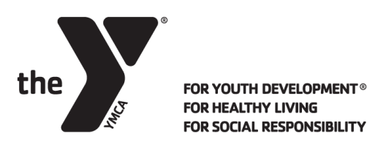
BEFORE/AFTER SCHOOL CARE
Y-Club’s serving Hamilton Local Schools
(Hamilton Elementary & Intermediate Schools)
Weekly Rates - 2019-2020 School Year
Tuition Payment Structure and Fee information

School Age Care is billed weekly based on type of care selected. The weekly fee represents one week’s tuition. The weekly fee may vary some weeks due to scheduled days off. Payments are due each Friday for the upcoming week of care. Advance payments may be made for future weeks of care.

We require automatic EFT with debit card or banking account, or an automatic credit card payment. This ensures worry-free, on-time payment and no late payment fees. When paying your registration fee, you may provide your credit card to be applied to weekly payments as well.

Automatic Payments are drafted on Friday mornings for the following week of care. You may occasionally have an EFT charge on Friday for past sessions if a previous payment was not processed successfully.

Weekly Care | Elementary Schools  K-6th Grades  Weekly Fee
Before Care Only opens at 7am | $36.00
After Care Only closes at 6pm | $47.00
Before and After Care | $80.00

Registration Fee: $25 Individual/$50 Family (two or more students)
Registration forms are to be completed online. The registrar will confirm acceptance of the forms and provide information to complete payment of registration fee online or with credit card. Payment of registration fee and completing payment agreement will confirm placement in the program.
Siblings will receive a 10% sibling discount which will be applied to the second and any additional siblings Y Club fees. Discount does not apply to registration fee or any previously reduced rates.
School District Employee Discount- Work for a district we serve? Receive 25% off Y-Club care.
Cancellations need to be communicated via email to the child care registrar and require a two week notice. We do not accept cancellations by phone.
Financial Assistance is available for those families who qualify. Child care fees will be based on a sliding scale. You may inquire about assistance with the child care registrar. The YMCA is also a recipient of Public Funded Child Care (Title XX).
School Days Out will be offered at the Eldon & Elsie Ward YMCA, North YMCA and the Vaughn Hairston YMCA. Please inquire at those locations for a schedule. Care is provided 7am-6pm. Registration for individual days will be available online or at those YMCA locations.
Thank you for choosing the YMCA Y-Club for your childcare needs.
QUESTIONS? Contact the Child Care Department at the Jerry L. Garver YMCA 614-834-9622
Child Care Registrar Email: garverregistrar@ymcacolumbus.org
Area Child Care Director: Kathryn Bowman kathryn.bowman@ymcacolumbus.org

